**TEST DRIVEN DEVELOPMENT REPORT**

**Why we chose this test?**

**The test we are reporting on tests if the calculation of coordinates for the map/search functionality are correct. We chose this test as it demonstrates the functionality of a complex algorithm which if implemented incorrectly would greatly affect the overall usability and reliability of the application. This test helped us greatly during our development as it allowed us to identify key issues with the map/search system, namely the confusion of which units we were meant to be using, miles or kilometres as the team had been using them interchangeably and no standard had been set prior to developing the test at the start of the week. The test helped us identify this issue and refactor our code accordingly.**

**Acceptance Test**

**We used an external tool to calculate the accurate coordinates and compared them with the result of the test in order to calculate whether our system was working correctly.**

**Evidence of tests and their uses**

HospitalSearchBar.test.js

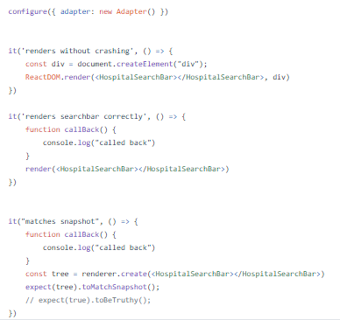

HospitalMap.test.js

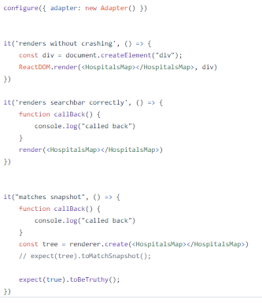

ProcedureList.test.js



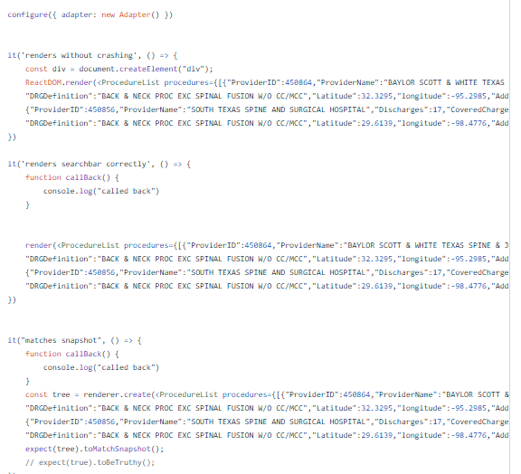

ProvCard.test.js

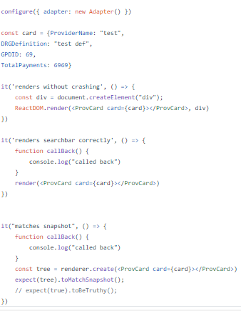

Card.test.js

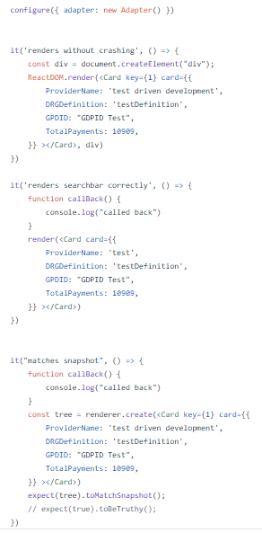

NewSearch.test.js